

Module

Coordinator:

Professor Sami Kafala



Supervisor:

Ms

.

Gill Whitney



Date of submission:

27

June

,

202

2



|  |
| --- |
|  |
| Emmanuel  Ayobola    Ol  adele              M00  859474 |



REAL ESTATE



MANAGEMENT SYSTEM



COURSE: Information Technology

and Business

Information System



Module Name:

Undergraduate Individual Project



Module Code:

CST3390



1. | P a g e

Table of Contents

DECLARATION ............................................................................................................................................... 4

ACKNOWLEDGEMENTS ................................................................................................................................. 4

ABSTRACT ...................................................................................................................................................... 4

1. CHAPTER 1 ............................................................................................................................................ 5
   1. INTRODUCTION ............................................................................................................................. 5
   2. BACKGROUND ............................................................................................................................... 5
   3. PROBLEM DEFINITION................................................................................................................... 6
   4. AIMS AND OBJECTIVES OF PROJECT ............................................................................................. 7
      1. AIMS .......................................................................................................................................... 7
      2. OBJECTIVES ............................................................................................................................... 7
   5. RESEARCH STRUCTURE ................................................................................................................. 7
   6. RESEARCH QUESTIONS .................................................................................................................. 7
   7. PROJECT FEATURES ....................................................................................................................... 7
   8. PROJECT DELIVERABLES ................................................................................................................ 7
   9. PROJECT PLAN ............................................................................................................................... 8
   10. RESOURCES NEEDED ..................................................................................................................... 9
   11. EVALUATION ................................................................................................................................. 9
   12. REPORT OUTLINE .......................................................................................................................... 9
   13. CHAPTER SUMMARY ..................................................................................................................... 9
2. CHAPTER 2 .......................................................................................................................................... 10
   1. LITERATURE REVIEW ................................................................................................................... 10
   2. ABSTRACT .................................................................................................................................... 10
   3. INTRODUCTION ........................................................................................................................... 10
   4. REAL ESTATE DEFINITION ............................................................................................................ 11
   5. REAL ESTATE MANAGEMENT SYSTEM CONCEPT ........................................................................ 11
   6. EXISTING REAL ESTATE MANAGEMENT SYSTEMS IN USE ........................................................... 12
      1. RIGHT MOVE ........................................................................................................................... 12
      2. SAVILLS .................................................................................................................................... 12
      3. THE STAY CLUB ........................................................................................................................ 13
      4. PROPERTY PRO ........................................................................................................................ 13
      5. NIGERIA PROPERTY CENTRE.................................................................................................... 13
      6. PRIVATE PROPERTY ................................................................................................................. 14
   7. SYSTEM COMPARISON OF EXISTING SYSTEMS ........................................................................... 14
   8. RESEARCH METHODOLOGY ........................................................................................................ 15
   9. CHAPTER SUMMARY ................................................................................................................... 15
3. CHAPTER 3 .......................................................................................................................................... 16
   1. RESEARCH METHODOLOGY ........................................................................................................ 16
   2. METHODOLOGY .......................................................................................................................... 16
   3. SYSTEM ANALYSIS ....................................................................................................................... 16
      1. SYSTEM DESIGN ...................................................................................................................... 16
      2. SYSTEM DEVELOPMENT AND TESTING ................................................................................... 17
      3. RESULT AND DISCUSSION ....................................................................................................... 17
   4. CHAPTER SUMMARY ................................................................................................................... 17
4. CHAPTER 4 .......................................................................................................................................... 18
   1. SYSTEM ANALYSIS AND DESIGN .................................................................................................. 18
   2. INTRODUCTION ........................................................................................................................... 18
   3. SYSTEM ANALYSIS ....................................................................................................................... 18
      1. ANALYSIS OF THE EXISTING SYSTEM FLAWS (NIGERIA AS A CASE STUDY) ............................. 18
      2. DIFFICULTIES AND GAPS OF THE EXISTING SYSTEMs IN NIGERIA ........................................... 18
      3. REQUIREMENT ANALYSIS ........................................................................................................ 19
      4. ANALYSIS OF THE PROPOSED SYSTEM .................................................................................... 21
      5. DESIGN OF THE NEW SYSTEM ................................................................................................. 21
      6. DATA FLOW DIAGRAM ............................................................................................................ 21
      7. USE CASE DIAGRAM ................................................................................................................ 22
      8. ENTITY RELATIONSHIP DIAGRAM............................................................................................ 24
      9. SEQUENCE DIAGRAM .............................................................................................................. 24
      10. WIREFRAME OF THE SYSTEM .............................................................................................. 25
   4. CHAPTER SUMMARY ................................................................................................................... 25
5. CHAPTER 5 .......................................................................................................................................... 26
   1. DEVELOPMENT AND IMPLEMENTATION .................................................................................... 26
   2. HOW TO RUN THE WEB APPLICATION. ....................................................................................... 28
6. 3............................................................................................................................................................ 28
   1. SYSTEM IMPLEMENTATION ........................................................................................................ 29
      1. LOGIN SCREEN ........................................................................................................................ 29
      2. GUEST USER ............................................................................................................................ 29
      3. USER HOME SCREEN ............................................................................................................... 30
      4. ADMIN DASHBOARD ............................................................................................................... 30
      5. USER PROFILE PAGE ................................................................................................................ 31
      6. MORTGAGE CALCULATOR ....................................................................................................... 31
      7. ADMIN LOGIN PAGE ................................................................................................................ 32
      8. CHOICE OF PROGRAMMING LANGUAGE ................................................................................ 32
      9. HTML - (HYPER-TEXT MARKUP LANGUAGE) ........................................................................... 32
      10. CSS - (CASCADING STYLE SHEETS) ....................................................................................... 32
      11. JAVASCRIPT ......................................................................................................................... 33
      12. SQL (STRUCTURED QUERY LANGUAGE) .............................................................................. 33
      13. PHP (Hypertext Preprocessor) ............................................................................................ 33
      14. DEVELOPER'S ENVIRONMENT ............................................................................................. 34
   2. CHAPTER SUMMARY ................................................................................................................... 34
7. CHAPTER 6 .......................................................................................................................................... 35
   1. SYSTEM TESTING AND RECOMMENDATION FOR FUTURE WORKS ............................................ 35
   2. TEST CASE .................................................................................................................................... 35
   3. RECOMMENDATIONS FOR FURTHER WORK ............................................................................... 36
   4. CHAPTER SUMMARY ................................................................................................................... 36
8. CHAPTER 7 .......................................................................................................................................... 37
   1. CONCLUSION, SUMMARY AND RECOMMENDATIONS ............................................................... 37
   2. BRIEF SUMMARY ......................................................................................................................... 37
   3. CONCLUSION ............................................................................................................................... 37
   4. RECOMMENDATION ................................................................................................................... 37
9. REFRENCES .......................................................................................................................................... 38
10. APPENDIX ............................................................................................................................................ 40
    1. APPENDIX “A” MEETING LOG WITH SUPERVISOR ...................................................................... 40
    2. APPENDIX “B” ETHICS FORM ...................................................................................................... 42
    3. CONSENT FORM .......................................................................................................................... 44
    4. OTHER ......................................................................................................................................... 44

# DECLARATION

I confirm that the designed methodology "The proposed system Real estate management system for property services" offered to Middlesex University is individual research of my study and enhancement performed with the assistance of my module coordinator Professor Sami Kafala and my guidance of Ms. Gill Whitney my supervisor. All resources collected from different sources have been completely authorized.

EMMANUEL OLADELE M00859474

# ACKNOWLEDGEMENTS

I would like to give thanks to God for providing me with the academic consistent performance as well as the resolution to finish this task. I would like to express my gratitude to Ms. Gill Whitney, who serves as my supervisor, as well as Professor Sami Kafala, who serves as my Module-Coordinator. I owe her a debt for allowing her experience to continue for a longer period of time, for being truthful about the benefits, and for giving me helpful assistance as well as inspiration.

First and foremost, I want to take advantage of this opportunity to express my gratitude to my parents, Mr. And Mrs. Oladele, as well as to each and every one of my siblings, for the unwavering support, assistance, and love they have shown me throughout the years. They were not only the continuous basic springtime but also the mainstay of the system that I was able to develop, and without them, I would not have had the ability to do so. I offer my service to both them and to God in exchange for this responsibility.

# ABSTRACT

This research project will focus on developing a home management and estate representative system for professionals and other individuals working in the property industry. This will save hours and inspire management companies to offer further by enabling them to monitor leads, take care of listings, and also market to new potential customers quickly. Additionally, this will encourage property managers to offer further by enabling them to offer more. The primary objective of the development of this project is to provide assistance to those nations which do not keep their property information in a digital format but, rather, keep the information in a data format that is susceptible to being lost. The address of the residential property, a synopsis of the building, the rental rate, and any readily available centers are the details that are required to register the building that is available. Each user of the Proposed System will be required to have a unique login ID in order to be recognized, and a password complexity plan will be applied in order to keep the system secure. This access control management system will certainly be in place when the Proposed System is put into operation.

# 1 CHAPTER 1

## 1.1 INTRODUCTION

In this section, the background, difficulties, targets, and objectives of the research in question are posed as well as reviewed. It will provide a fundamental comprehension of the property management system.

## 1.2 BACKGROUND

The sale of real estate and land is one of the most traditional forms of asset transfer, and it's one that a lot of people have had success with. It is nearly impossible to overstate the significance of agricultural, domestic, and industrial real estate assets throughout the course of human history. The human structure, matrimony foundations, interstate relationships, and more generally, increased socio-economic groups have been influenced by and concurrently have affected the functioning of real property sales. This is because the earth has been a significant factor in all of these aspects of human life. (Bardhan and Edelstein, 2007). Because of the intricate communication that real estate sales have had over the years with human, governmental, cultural, and industrial organizations, as well as the collision of various technological advancements, the task of determining what is or was known, what is unknown, and what is unknowable in the real property business and real estate financing is a particularly challenging one. (Bardhan and Edelstein, 2007)

Because of the persistently high demand for housing in Nigeria, the country's real estate market has a lot of problems. Real estate has become deficient, fraudulent, and inadequate. The real estate industry has been inundated with numerous organizations, some of which are fraudulent while others are not, making it difficult to confer with real estate organizations (Samson Itoje, 2022). In Nigeria, property management is still not well defined, and as a result, different practitioners have different approaches. It is done by a variety of professionals as well as people who are not professionals, and it is not organized. The Law of Contract and social responsibilities govern property management, but lease agreements between landlords and tenants pay only passing attention to the topic. Property management is governed by both of these areas (Oyedele, 2013). In recent years, purchasing or renting a home in Nigeria has become an extremely challenging endeavor. For instance, if you want to buy land in Nigeria, you need to get in touch with an agent. That agent will be the one to compile a list of all the available land and provide it to you. You then make the decision to find a lawyer to assist you in examining the land and the documentation associated with it in order to protect yourself from being defrauded.

The researcher suggests establishing an estate management practice in order to alleviate stress, protect oneself from being taken advantage of, and obtain accurate information regarding the property that is to be purchased. An application that runs on the internet is going to make use of this system. Customers will certainly have the ability to view their homes as well as the homes that are available to be purchased using this system. This system will validate necessary records, such as property deeds, in order to guarantee the legitimacy of the landowners as well as the customers. Certification of Occupancy, or "C of O" for short "A Certification of Occupancy is a legal document that confirms an individual's ownership of land in Nigeria. This document is issued by the government and serves as proof of ownership. The federal government is granted the authority to seize any plot of land or residential property at any time, with or without a certificate of occupancy, and without making any compensation payments "(MIXTA AFRICA, 2022), a legitimate home loan, an action of assignment or conveyance, and an act of presentment (Resolution Law practice, 2021). For the purpose of confirming the customer's identity, this system will additionally collect supporting documents such as national identification cards (NIN), bank confirmation numbers, and so on. Additionally, responses concerning landowners will be provided by this web application.

## 1.3 PROBLEM STATEMENT

In the real estate industry, a piece of web software known as a Real Estate Management System (REMS) is used to control all operational operations and procedures. These include property management, the control of real estate firms, brokers, and clients, as well as the control of financial transactions. It provides in-depth reports for managing the efficiency and performance of real estate agencies, which in turn enables management to make more informed decisions (DM Consulting Services, 2005).

A **real estate management system** is a web application that provides property owners and agents with the ability to manage the operational process and activities and process of their properties, beginning with the management of the property and continuing on to the agent or clients or agents and continuing on to the financial transactions. This software makes all aspects of property management much simpler, from attracting new clients to renting out or selling real estate. A property management system is another term that can be used to refer to a real estate management system. Real Estate Management systems make it possible for property owners, maintenance staff, and real estate agents to manage the day-to-day operations of their respective properties. When it comes to property maintenance for commercial properties, some of the most important focus areas include risk management, maintenance, communication, and the satisfaction of tenants. (Wikipedia, 2022). The use of real estate management software makes it a breeze to handle all aspects of property management, from attracting new clients to renting out or selling real estate. The control or supervision of a property or properties by an individual, an agent, or an organisation is referred to as property management. The purchasing and selling of land is a part of property management, as is the analysis of pertinent issues from both a practical and a theoretical perspective. Property management also involves the buying and selling of land. Aspects of a practical nature, such as the valuation of real estate, fundamental questions (such as how a company ought to organise its marketing strategies to attract customers), and various strategies for real estate agencies are all included (Palm, 2015).

The concept that property management needs to incorporate computers and other forms of information technology into the monitoring of residential and commercial real estate is an issue that has generated a significant amount of interest in home research (Deakin, 2019). Since personal computers became more readily available to the general public, it has actually become a significant area for improvement for home specialists to focus on. An Effective Property Management System Can Also Be A Challenging Action That Requires Necessary Understanding, Ability, and also Ideal Technical and Business Capabilities as well as Assets to Properly Maintain and Improve Property Value Through Its Obsolescence An Effective Property Management System Can Also Be A Challenging Action That Requires Necessary Understanding, Ability, and also Ideal Technical (Huang, 2000). Building resources, which include show up and structures, are an essential asset for all kinds of businesses, including neighbourhood professionals and central federal governments.

These assets can be anything from a house to a large office building. The residential property asset contributes to the success of these organisations in a manner that is analogous to that of various other assets, including human resources, financial resources, and information (Rhodes, 2008). These activities are going to take place inside of an agreed-upon calculated system in which there is a need to keep hold of the requirement of updating and blending interface wherever it is possible, recognising various other openings for the development of potential, and meeting the proprietor's legal and social responsibilities to the neighbourhood (James and also Donald 2000). In spite of the fact that those resources were provided with a significant amount of funding, those resources will still contribute respect to a company that has management that is both sensible and frequently innovative.

## 1.4 AIMS AND OBJECTIVES

The primary goal of this proposed system are to design and implement a web app for managing real estate properties that can be used on smartphones or a laptop since it is web-based system. The aims and also the objectives are listed below.

### 1.4.1 AIMS

This project aims to create a web app that will be able to manage all real estate management processes, manage properties, and search for clients.

### 1.4.2 OBJECTIVES

These project objectives are;

* Create a system that will ease the stressful process of a real estate management system.
* A system where people will be able to buy and sell properties without the fear of being scammed,
* To create a system where users will be able to monitor their properties themselves.

## 1.5 RESEARCH STRUCTURE

The research structure section not only outlines the overall project strategy with a Gant chart, but it also outlines the prototype of the deliverables that will be produced as part of this project.

## 1.6 RESEARCH QUESTIONS

* What are the challenges of real estate management in Nigeria?
* What is the effect of adequate management of real estate on its value?
* What are the solutions to the problems of the real estate management system in Nigeria?

## 1.7 PROJECT FEATURES

* Registration and Login
* Admin Portal
* Validation Functionality
* Search Functionality
* Question and answer Forums
* Reports Functionality
* User Management
* Graphical Functionality
* Map Functionality

## 1.8 PROJECT DELIVERABLES

This project deliverables are dissected into five important deliverables which are listed below:

* **Literature review**

Literature review is the process of summarizing and analyzing the whole project previous research work that could be worked on in proposed system Identify the controversy also highlight any gaps in the existing system which is the first stage of this project.

* **Wireframes**

Wireframing is the process of representing the actual app functionalities with images to have an idea of how it should look like before implementing the actual design which is the next stage of this project after literature review.

* **Splash Screens**

After wireframing, designing the splash screens is the next stage because it’s the process of representing the graphical control flow of the web application which means it entails the window screen containing different images such as logo, the version of the used software and so on.

* **Designing the project:**

This is the next stage after designing the wireframes and the splash screens for the project the implementation of the project can now commence as it entails all the app functionalities.

* **Web application functionalities**

In this stage all the project features will be implemented to make the project meets the needs we want it to meet.

* **Report**

After completion of the project, it is needed to document the process of the project and that is where the project report comes in which may include the **Introduction, abstract, Project requirements, analysing existing system, analysing and designing the proposed system, implementing all the functionalities, testing to see if all the application needs is been met, conclusion and appendix.**

## 1.9 PROJECT PLAN

This project timetable utilizes the chart listed below to manage time control to guarantee that the recommended project's advancement can be completed in a prompt way. The proposed project will certainly begin promptly the project proposal has been accepted. The graphical Gant chart show how the project process was carried out.

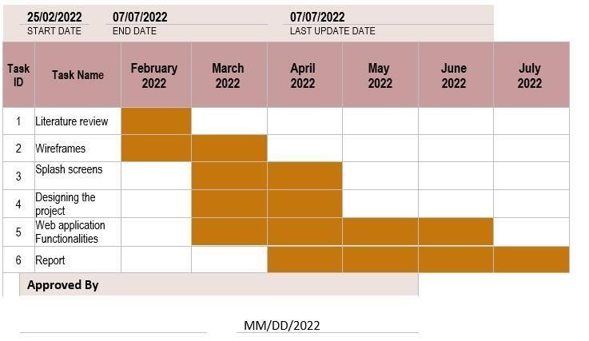

*Figure 1 Project Gantt Chart*

## 1.10 RESOURCES NEEDED

* Web application editor (Visual Studio codes, Sublime text etc.) for coding the web application
* Hosting Service: for hosting the web application
* Database where all the records will be stored instead of using a paperwork

## 1.11 EVALUATION

This is a method for carrying out an in-depth analysis of completed goals as well as activities contained within the implementation. If the implementation fails the analysis, then it is not ready for screening; if it does pass, then the responses are considered, and the application is reworked to fulfil those issues. The cycle will keep going around and around until the goal is finally reached.

## 1.12 REPORT OUTLINE

This research project report is divided into seven chapters which consist of the project documentation and research made on the proposed system.

## 1.13 CHAPTER SUMMARY

Up until this point, this phase has actually been effective in establishing the basis for this study by specifying the problems that need to be fixed, the objectives and goals of the study, defining the anticipated output, the task chart to finish the research project, and also lastly the documentation structure to explain what to expect from the documentation.

# 2 CHAPTER 2

## 2.1 LITERATURE REVIEW

This part provides detailed research regarding the real estate monitoring and management system that is used for running rental homes. It was preserved by highlighting a number of different processes and styles that were used in the development of the real estate monitoring and management.

## 2.2 ABSTRACT

Real estate falls under the category of "real property," which encompasses land as well as anything that is permanently attached to it, regardless of whether or not it was created by humans. As the global population continues to rise, there will be a greater demand for real estate, which brings with it the responsibility of maintaining and managing property. This field of work is known as real estate management. Because people in developing countries like Nigeria are still wary of being taken advantage of, traditional methods are used to manage real estate. The researcher has made the decision to design a system that will be implemented in the form of a web application in order to make the traditionally stressful process of real estate management systems more manageable. This system will be able to assist property owners in renting out their homes or selling their homes more quickly. Clients are able to search for available properties using this system, which provides information about the price, location, and owner of the property. Property owners have the ability to edit or change various property details using this system. This system will be able to filter available properties according to the requirements or preferences of the client.

## 2.3 INTRODUCTION

One of the oldest assets that people have owned for the purpose of sales or shelter is real estate. The expansion of the global population has led to the development of the real estate market over time. There is a consistent increase in the demand for housing due to the ongoing development of the world, which causes people to experience difficulties in obtaining shelter. The vast majority of people around the world work with real estate agencies when purchasing, leasing, or selling lands, houses, properties, and other types of real estate. Real estate management systems can vary greatly from one country to the next. As the number of people living in Nigeria continues to rise, there is a corresponding increase in the amount of property that must be maintained and managed. This type of work is referred to in the business world as real estate management or property management system.

There are many facets to property management, some of which include managing the accounts and finances of the real estate and residential properties, as well as participating in or initiating litigation with tenants, contractors, and insurance agencies. Other aspects of property management include managing the accounts and finances of commercial and industrial properties. At other times, litigation is regarded as its own distinct function, one that is reserved for specially trained attorneys. It is possible that a property manager will have an attorney working for them, despite the fact that this responsibility will be outlined in the job description of the person in question. Evictions, non-payment, harassment, reduction of pre-arranged services, and public nuisance are typically the types of legal issues that receive the most attention from residential property managers. Additionally, landlordtenant law receives a great deal of focus. Because of this, it is absolutely essential for a public residential property manager to be up to date on all of the applicable fair housing laws and practises at the municipal, county, state, and federal levels. Computer-assisted facility management is becoming an increasingly important tool for real estate management in developed nations. This tool also helps with facility management (CAFM).

Due to the widespread fear of being taken advantage of, traditional methods of property management are still used in Nigeria. Only five percent of all buyers opt to purchase a home from the seller in the seller's direct transaction (Dragomir Simovic, 2022). When it comes to purchasing a home, the vast majority of people (89 percent) go through the process of first consulting a real estate agent. It is unusual for buyers to initiate contact with homeowners directly. In more than half of the instances, they already have a personal relationship with the person from whom they are purchasing. Another 5% are interested in making their purchase from the function Object() { [native code] } directly (Dragomir Simovic, 2022). The existence of different histories, cultures, and practises all contribute to the development of differences. (Gross, M. & Lin, C, 2020)

## 2.4 REAL ESTATE DEFINITION

Real estate is the property that consists of land, infrastructures, and any other property with perpetual advancement or immovable properties attached to the land, as well as natural resources (such as minerals, water, and trees,) or manufactured resources. Real estate also includes resources that are either natural (such as minerals, water, and trees) or manufactured (such as manufactured resources) (such as buildings, homes, fences, and bridges). The difference between real estate and personal property is that real estate does not include movable properties like furniture, televisions, automobiles, accessories, and so on. Personal property does include all of these things. Additionally, real estate can be split up into two distinct categories: residential real estate and commercial real estate (James Chen, 2021). According to Bello (2008), real estate is more than just a place to sleep; it encompasses all facilities located within and around it, as well as a package of services that includes both the product and the process of providing those services. The process of maintaining and developing real estate encompasses all aspects of management, regardless of whether it relates to the economy, society, or the physical environment (Project Championz, 2016).

## 2.5 R.E.M.S CONCEPT

A **real estate management system** **(R.E.M.S)** is a system that is implemented in a web application that enables property owners or representatives to manage the functional process, activities, and procedures of their residential or commercial properties, beginning with the management of the residential property to the representative, clients, or agents, and ending with monetary transactions. This type of system allows property owners or representatives to manage the functional process, activities, and procedures of their residential or commercial properties. This software makes every aspect of property management much easier, from the recruitment of tenants to the marketing and sale of the structure itself. There are two names for the same thing: a real estate management system and a property management system. The day-to-day operations of residential properties can be managed by real estate agents, maintenance personnel, and property owners with the help of real estate management systems. The management of real estate involves a number of important subfields, the most important of which are risk monitoring, maintenance, interaction, and lease fulfilment. Finding customers, renting out or selling a property, and other aspects of real estate management can all be made easier with the help of software applications. Building administration is a term that refers to the control or supervision of residential or commercial properties by an individual, a representative of an organisation, or an organisation itself. The buying and selling of land is part of real estate management, and so is the gathering of relevant information from both a practical and a theoretical point of view. Aspects of real estate practise such as residential or commercial property valuation, critical questions (such as how a company ought to organise its marketing strategies to attract customers), and real estate agency practises, amongst others, are examples of such issues (Palm, 2015).

Researchers from a number of different institutions have looked into the problem of unethical behavior in the Nigerian context. Osahon (1981) investigated the multifaceted nature of unethical behavior in Nigeria from a variety of perspectives. Both Nwankwo (1985) and Bolaji (1985) emphasized the necessity of economic and political nationalism, moral leadership, and the requirement of education for new leadership in Nigeria. Both authors also emphasized the need for education. Ogundele et al. (2009) presented research-based solutions to the multi-faceted problems of unethical behavior in Nigeria. These solutions were presented in Nigeria. The author determined that there are global causes, one of which is the disregard for social norms and values. motivational causes, political causes, and legal and judicial causes have all been identified as major contributors to the unethical behavior and practices that are prevalent among Nigerian professionals.

Many people are interested in real estate research studies because of the idea that real estate management requires the use of computers and information technology in the management of residential or commercial property (Deakin, 2019). Since the personal computer has become more accessible to the general public, the computerization of real estate management tasks has become a significant area for innovation among house professionals (Bergsman Steve, 1997). An efficient real estate management structure can also be a demanding action that must necessarily involve critical awareness, capability, as well as appropriate distinguished and business capacities, as well as properties, in order to successfully proceed and also take a step in residential or commercial property value through irrelevancy (Huang, 2000). These exercises are going to take place inside of a tactical system that has a requirement to handle the demand for revamping and merging user interfaces wherever it is practicable, identifying various additional areas for potential innovation, and satisfying the owner's legal and social obligations to the area. (James and Donald 2000). [Citation needed] They will also include esteem to a company with sensible and frequently innovative management because a large number of resources were provided to those resources, and because those resources were also provided with resources. Residential property resources, such as displays and structures, are an important possession for all different kinds of businesses, including community experts and central governments. These resources can be found in a variety of settings. In the same way that other assets, such as human capital, financial resources, and data, contribute to the success of those businesses, property ownership also does so (Rhodes, 2008).

2.6 EXISTING REAL ESTATE MANAGEMENT SYSTEMS IN USE The case study are UK and Nigeria:

### 2.6.1 RIGHT MOVE

Rightmove is the most popular real estate website in the United Kingdom and the largest property marketplace in that country. Rightmove is the only website that allows homebuyers and renters in the UK to view almost the entire property market in a single location, and it is completely free to use for consumers. Because they can rely on the speed and availability of our platforms to view more properties for sale and to rent than anywhere else, Rightmove has become the place that consumers turn to and return to first when they think about moving home. This is because Rightmove has become the go-to destination for consumers when they are considering moving (Rightmove, 2021).

### 2.6.2 SAVILLS

Savills plc is a British company that provides real estate services and has its headquarters in London. It can be found on the London Stock Exchange, and it participates in the FTSE 250 Index (Watson, 1977). Savills is one of the most successful real estate companies in the world, and it was established in the United Kingdom in 1855. We have 600 offices located across the Americas, Europe, Asia Pacific, Africa, and the Middle East, which gives us a global perspective on our experience and expertise. Because of our size, we have access to a diverse range of specialist and local knowledge, and we take great pride in providing advice that is at the top of its field as we guide individuals, businesses, and institutions toward more sound real estate choices (Savills, 2021).

### 2.6.3 THE STAY CLUB

Private studios all the way up to premium suites are available for guests to choose from at The Stay Club Camden. Our Camden studios to let are ideal for students who value their own sense of privacy as well as for couples who want to share the experience of attending university together. Even groups of up to four friends who want to live together in student housing can find a place to call home in one of our suites. The spaces that are provided produce an atmosphere that is excellent for both work and recreation. They are roomy and bright, and come equipped with a kitchenette, a study area, and a wet room. Free high-speed Internet access, linen, towels, and basic kitchenware are provided in each of the accommodations (The Stay Club, 2021).

### 2.6.4 PROPERTY PRO

PropertyPro.ng is Nigeria's most prominent online real estate and property centre marketplace. We provide users with the best property search experience possible, both online and offline, by connecting them with real estate agents who are legitimate and have been verified. Our web-based platform for property sales and rentals allows us to accomplish this. With over 60,000 property listings in the Nigerian property market, which include properties such as homes, houses, lands, shops, office spaces, and other commercial properties, small, medium, and large-scale real estate companies in Nigeria that want to scale up the sales and rentals of their properties can partner with PropertyPro.ng. PropertyPro.ng features properties such as homes, houses, lands, shops, and office spaces, among other commercial properties (PropertyPro.ng, 2020)

### 2.6.5 NIGERIA PROPERTY CENTRE

The Nigeria property centre is a website specialising in real estate and property in Nigeria. It features listings of available properties, including those that are for sale, rent, and lease. We make it simple for people in Nigeria who are interested in buying or renting real estate to find information about homes, houses, lands, shops, office spaces, and other commercial properties that are currently available. The Nigeria Property Centre serves as a venue for commercial and residential real estate listings made available by Nigerian individuals and companies alike. The Nigeria Property Centre (NPC) is unequivocally the most popular real estate website in Nigeria, boasting a large number of users, advertising members, and properties. Our advertisers include real estate professionals such as estate agents, letting (rental) agents, new homes developers, and Nigerian private property owners who offer properties within Nigeria for sale to individuals interested in purchasing real estate there.

(Nigeria Property Centre, 2022) [citation needed].

### 2.6.6 PRIVATE PROPERTY

The legal designation for the ownership of a piece of real estate by a non-governmental legal entity is known as private property. One can tell the difference between public property, which is owned by the state, and collective or cooperative property, which is owned by a group of organisations that are not part of the government. Private property falls into the first category. The line that is drawn between private and personal property can be murky, depending on the political philosophy being discussed; socialist perspectives, on the other hand, draw a clear line between the two types of property. The political system of a nation is what establishes the parameters of private property law and ensures that it is followed. (Boudreaux, Karol, 2022).

## 2.7 SYSTEM COMPARISON OF EXISTING SYSTEMS

|  |  |  |  |  |  |  |  |
| --- | --- | --- | --- | --- | --- | --- | --- |
| **Features** | **Rightmove** | **Savil ls** | **The**  **Stay**  **Club** | **Property Pro** | **Nigeria Propert y Centre** | **Private**  **Property** | **Proposed System** |
| **User**  **Onboarding**  **(Login and**  **Signup)** |  |  |  |  |  |  |  |
| **User profile**  **(User, seller, or agent)** | × | × | × |  |  | × |  |
| **Listing and database** |  |  | × |  |  | × |  |
| **Filter and**  **Categories** |  |  |  | × |  | × |  |
| **Property Profiles** |  |  |  |  | × |  |  |
| **Short Listing (Favorites)** |  |  | × |  |  |  |  |
| **Maps** |  |  |  |  | × | × |  |
| **Direct**  **Message** | × |  |  |  | × |  |  |
| **Validation** |  |  |  | × | × | × |  |

*Figure 2 Comparison between the existing system and the proposed system*

## 2.8 RESEARCH METHODOLOGY

A significant amount of research was conducted on real estate, buildings, lands, and residential properties, amongst other related topics, in order to achieve a far superior comprehension of the Real Estate Monitoring System as well as the people who make up its membership. The research was reliable because it examined historical examples of Real Estate applications and development over a long period of time. To conduct the necessary research and programming for the development of property management software applications, the necessary equipment has also been included in this package. During the process of gathering information, a number of online collections, databases, and properties were utilized; however, the vast majority of the material was inferred from Middlesex University's online data source reach, which included.

* Middlesex Library
* Science Direct
* Taylor & Francis Group
* IEEE Xplore
* Emerald Insight ➢ Research Gate

With the help of google scholar. The researcher researched on existing research papers on the research topic and looked for cases relating to the research topic. The researcher also investigated the existing systems relating to the research topic and compared them to the existing system.

## 2.9 CHAPTER SUMMARY

This chapter has provided an overview of the various property management software programs and discussed the impact these programs have in actual reality. An Estate management system can be utilized as a means of acquiring a residential or commercial property without the stress of being afraid of being overpowered by the estate agents. This can be accomplished through the utilization of this method.

# 3 CHAPTER 3

## 3.1 RESEARCH METHODOLOGY

This section discusses the procedures that are going to be carried out during the course of this research project. In addition, the concept of the research study as well as the ethical considerations that need to be taken into account are explained in this paper.

## 3.2 METHODOLOGY

During the process of putting this development into action, a measurable information analysis study will be implemented, and also it is possible to suggest that this will take place regardless of the theoretical perspectives held by customers. The technique was chosen because it is simple to understand and simple to interpret; Figure 3 outlines the stage of evaluation that needs to be adhered to in order to achieve the desired outcome. The method was selected because of its simplicity.

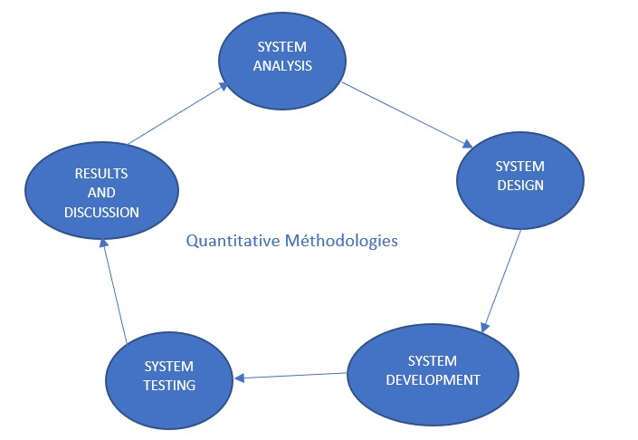

Figure 3 Quantitative Methodology approach

## 3.3 SYSTEM ANALYSIS

This phase consists of this research, and needs will definitely be gathered through integrated real property management framework evaluation and analysis to improve the technology during this phase. Examining the current Real Estate administration system is the objective of this step. Additionally, the design of the complete system will be presented at the end of the step, along with an explanation of how it will contribute to the overall improvement of the system.

### 3.3.1 SYSTEM DESIGN

During this stage, you will need to create a comprehensive depiction of the functioning component of the application. This will be done through the use of diagrammatic structures.

### 3.3.2 SYSTEM DEVELOPMENT AND TESTING

After the user's needs have been satisfied by the layout, the application will be concentrated on the layout using Aesthetic Workshop. After the application, a software program check will be done on the project to ensure that it satisfies the requirements that were proposed.

### 3.3.3 RESULT AND DISCUSSION

The results of the evaluation will certainly be obtained at this time and also contrasted to testing to see if all criteria have been satisfied. After that, a report will certainly be provided to evaluate all the condition of the task in order to allow the research study job to be approved as complete.

## 3.4 CHAPTER SUMMARY

This section discusses all of the procedures that need to be followed throughout the process of conducting that study as well as all of the factors that are essential to the accomplishment of this task in a short period of time.

# 4 CHAPTER 4

## 4.1 SYSTEM ANALYSIS AND DESIGN

4.2 INTRODUCTION

The researcher is going to perform an analysis of the system (Real Estate Management System) and illustrate how the system is going to be designed in the next chapter, which is titled ("System Analysis and design."). In addition to analysing the system itself (a Real Estate Management System), we will also analyse the business processes and requirements that are associated with the system.

## 4.3 SYSTEM ANALYSIS

In a number of countries on the African continent, such as Nigeria as an example, the management of real estate is carried out utilizing traditional methods. Real estate agents are responsible for the management of properties in Nigeria, including the valuation of properties and the sale of properties. It is the job of real estate agents to bring in new clients and maintain existing ones for their property owner’s clients.

The real estate agents are responsible for the management of a large number of properties, and the vast majority of them keep their records in a list (Property owners and their properties). When a customer contacts a real estate agent, the agent provides the customer with a list of available houses, and the customer selects the home that best meets his or her needs from the available options. After the client has selected the properties that they are most interested in, the real estate agent will then negotiate prices and make contact with the owner of the property. If the price that the real estate agent negotiates for the property is acceptable to the owner of the property, the owner will then release all of the necessary documents and the deal will be finalized.

### 4.3.1 ANALYSIS OF THE EXISTING SYSTEM FLAWS (NIGERIA AS A CASE STUDY)

The flaws of the existing system in use in Nigeria for real estate management system are:

* Agents tends to misplace files because most of them have a lot of properties and documents to handle.
* When property owners bring more properties, the documents to manage increases and makes managing the documents manually very difficult.
* Documents stored manually could be destroyed or misplaced, this could lead to fraudulent acts.
* It is likely for fraudulent personnel to scam users because the systems do not support validation method.

### 4.3.2 DIFFICULTIES AND GAPS OF THE EXISTING SYSTEMs IN NIGERIA

Nigeria real estate management system current gap and difficulties will be listed below.

* As the existing system in Nigeria has no validation. Anyone can pretend to be a property owner with fake pictures and addresses. This poses a threat to users and real estate management.
* The existing systems in Nigeria Have bad UI and UX. This makes it harder for new users to adapt to the web app.
* The existing systems in Nigeria have no preview of the property and less detail of the property. This makes it harder for users to make choices.

### 4.3.3 REQUIREMENT ANALYSIS

The real estate management system must be implemented in a secure web application with three different function the admin panel, the owner panel and the customer panel. The admin panel will be able to access the owner profile and the customer profile and check the owner’s listing.

|  |  |  |  |
| --- | --- | --- | --- |
| **No.** | **Requirement** | **Function / Category** | **Priority** |
| **1** | Allow users to create account and login | Functional Requirement | High  Priority |
| **2** | Allow users to access their profile | Functional Requirement | High  Priority |
| **3** | Allow users to View property listing | Functional Requirement | High  Priority |
| **4** | Allows users to filter Properties | Functional Requirement | Medium  Priority |
| **5** | Allows users to search for different properties from different categories | Functional Requirement | High  Priority |
| **6** | Allow users to give feedbacks | Functional Requirement | High  Priority |
| **7** | Allows users to search for properties of their choice in different locations | Functional Requirement | Medium  Priority |
| **8** | Allow the admin to preview owner and user profiles | Functional Requirement | Medium  Priority |
| **9** | Allows users to make transactions and manage it | Functional Requirement | Medium  Priority |
| **10** | This system improves potency and user stress | Functional Requirement | High  Priority |
| **11** | This system provides the location of listed properties | Functional Requirement | High  Priority |
| **12** | This system allows users to send message directly to the owners | Non-Functional Requirement | Low  Priority |
| **13** | The system must have a very good user experience and user interface | Functional Requirement | High  Priority |
| **14** | The system must be easy to use and adapt | Non-Functional Requirement | High  Priority |
| **15** | The system must be fast and reliable | Non-Functional Requirement | High  Priority |
| **16** | The system must be user friendly | Non-Functional Requirement | High  Priority |
| **17** | This system validates user identity and owner identity | Non-Functional Requirement | High  Priority |
| **18** | This system must be compatible with all operating system with different sizes | Non-Functional Requirement | High  Priority |
| **19** | This system must be easy to maintain | Non-Functional Requirement | High  Priority |
| **20** | This system must not be slow and must not crash under any circumstance | Non-Functional Requirement | High  Priority |

Table 1

### 4.3.4 SYSTEM ANALYSIS OF THE PROPOSED SYSTEM

The proposed system will be able to do the following functionalities:

The admin:

* The admin will be able to verify user identities and property documents.
* The admin will be able to add and remove real estate agents when necessary.
* The admin will be able to inspect owner profiles and user profile.

The Owners:

* The owners will be able to login and signup with their email or phone number with their selfgenerated password.
* The owners will be able to add properties ➢ The owners will be able to chat in the system.
* The owners will be able to view user profile and owner’s profiles The Client:
* The client will be able to login and signup with their email or phone number with their selfgenerated password.
* The client will be able to view user profile and owner’s profiles ➢ The client will be able to check property listing.

### 4.3.5 DESIGN OF THE NEW SYSTEM

The real estate management system will be implemented in a web app. In the web app the client side will be designed using HTML, CSS, and Java-script., the documents and all other data will be stored in a database (My SQL). The web app can be used on desktops, phones, Tablets and so on. It can also be used in different operating system like IOS, Android, Windows and so on.

### 4.3.6 DATA FLOW DIAGRAM

A data flow diagram, also known as a DFD, is a graphical or visual representation that employs a standard collection of symbols and notations in order to describe the operations of a company through the movement of information.

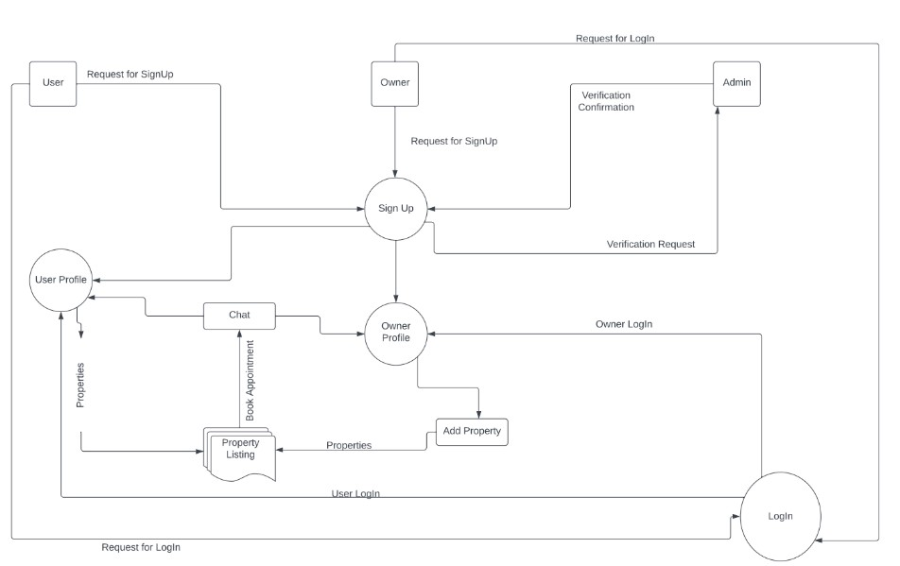

*Figure 4 Data Flow Diagram*

### 4.3.7 USE CASE DIAGRAM

A graphical representation of the various ways in which a user might interact with a system is called a use situation representation (USR for short). A use case representation will typically be accompanied by other types of layouts and will display a number of use cases as well as the various kinds of users that the system serves.

**Case Diagram of User**

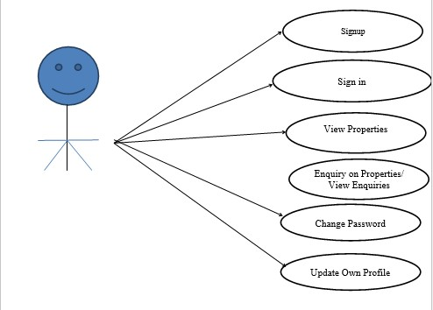

*Figure 5 User Case Diagram*

**Case Diagram of owners**

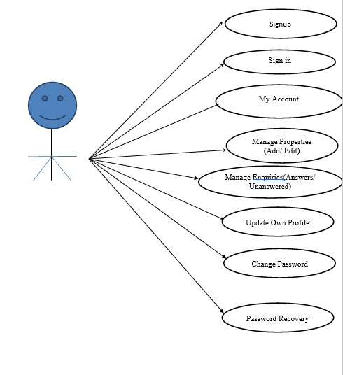

*Figure 6 Owners Case Diagram*

**Use case Diagrams Admin**

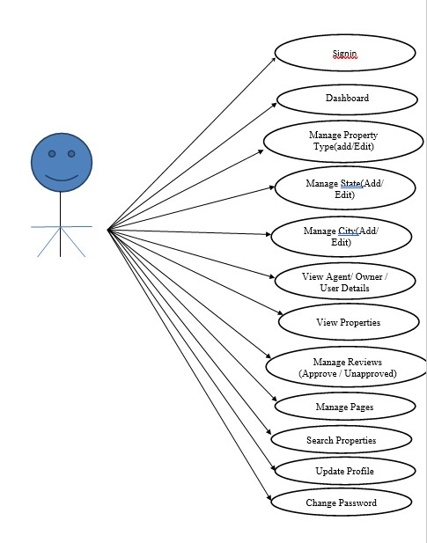

*Figure 7 Admin Use Case Diagram*

### 4.3.8 ENTITY RELATIONSHIP DIAGRAM

An Entity Connection Diagram (ECD) is a diagram that is used to display the relationship that exists between entity collections that are stored in a database. To put it another way, diagrams of emergency room layouts can help explain the logical structure of database structures. The development of ER representations is predicated on the utilisation of the following three fundamental concepts: entities, characteristics, and connections.

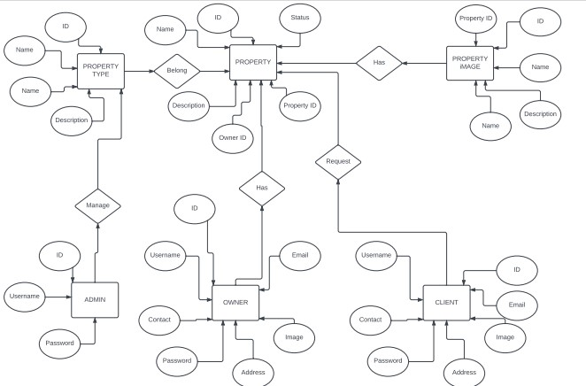

*Figure 8 ER Diagram*

### 4.3.9 SEQUENCE DIAGRAM

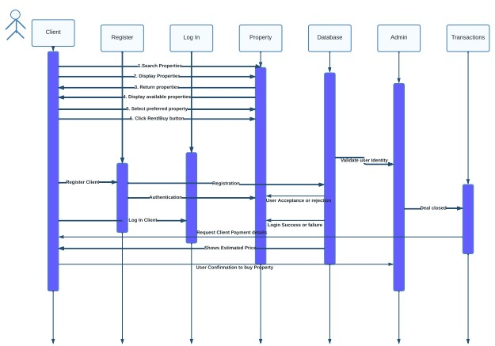 Interaction layouts that provide information on how procedures are carried out are known as sequence diagrams. They are able to understand the communication that takes place in the context of a cooperative endeavour. Using the vertical axis of the layout to represent time and revealing the order of the communication visually by using the horizontal axis of the layout to stand for what messages are sent out and when, series diagrams have a time focus and reveal the order of the communication.

*Figure 9 Sequence Diagram*

### 4.3.10 WIREFRAME OF THE SYSTEM

A wireframe is a diagram or plan that serves the purpose of assisting you, your programmers, and also your designers in thinking about and communicating about the structure of the software or web application that you are developing.

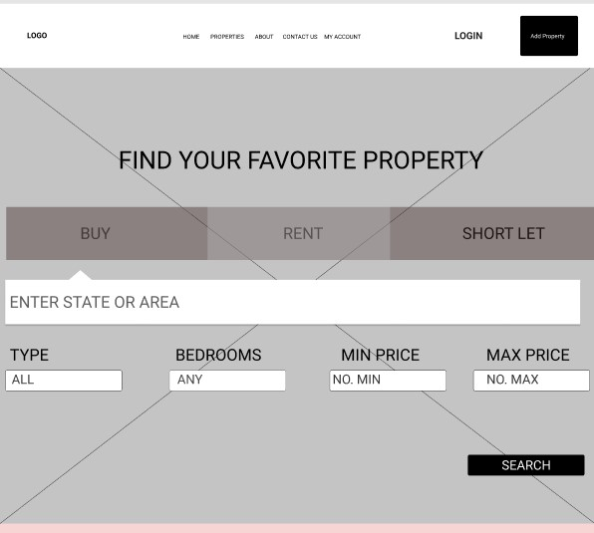

*Figure 10 Wireframe 1*

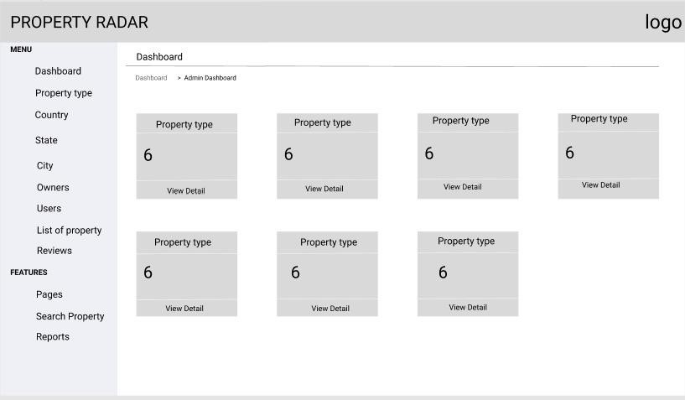  *Figure 11 Wireframe 2*

## 4.4 CHAPTER SUMMARY

The system evaluation and the use situation of the suggested application of the Property administration system occupied the primary focus of this entire section. Both the fully functioning and non-system requirements were described, in addition to the UML diagrams that were used to explain the interaction between the system and its users (use cases and interaction diagrams).

# 5 CHAPTER 5

## 5.1 DEVELOPMENT AND IMPLEMENTATION

### 5.1.1.1 INTRODUCTION

The previous chapter discusses about the system analysis which all the evidence of research will then in turn to the implementation of the real proposed system real estate management system. The purpose of this section is to see how the development and implementation of the web application is, which basically mean to know how the web application works in the real world. The requirement and the final completed working proposed system ‘’Real estate management”. The tools used, platforms used for the successfully build of the project.

### 5.1.1.2 SOURCE CODES

The proposed real estate management system project was built with PHP (Hypertext Preprocessor) encoded with HTML (Hypertext Markup Language) for the development, styled with CSS (Cascading Style Sheet), and scripted with JavaScript. Xampp was the server used to create the database and SQL was the language used to interact with the database.

### 5.1.1.3 SAMPLE OUTPUTS

This section shows the output of each project features which the graphical representation of these features proposed system will be shown below accordingly.

The picture below displays an overview of the new proposed real estate management system's results. **User home screen:** Figure 12 below represents the user’s home page. On this page, users can search for properties with respect to the city, property type, and property status. Users can also navigate to the about, properties, contact, user profile, change password, and logout.

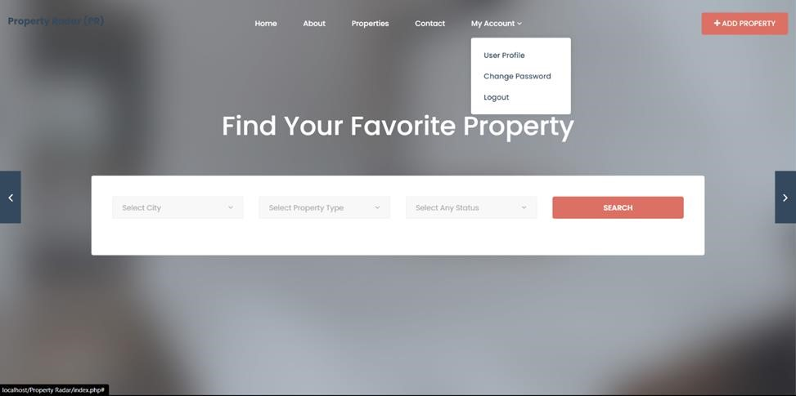

*Figure 12 User home screen*

**Guest Home screen:** Figure 13 below represents the guest home screen. On this page guest, users can navigate to the properties, about, and contact but are restricted to activities like adding property. Guest users can also navigate to log in where they can sign up (create an account) or they can log in if they have previously created an account.

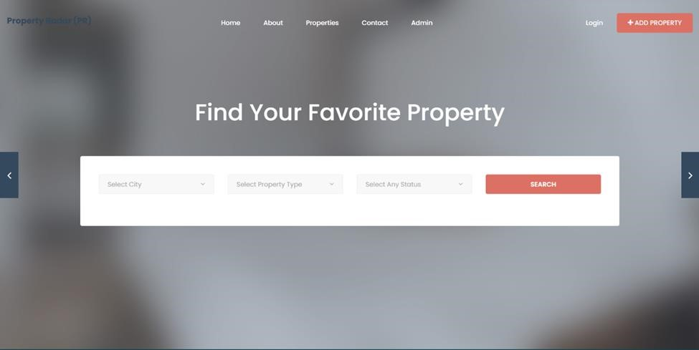

*Figure 13 Guest home screen*

**Admin Panel:** figure 14 below represents the admin’s dashboard. On this page, the administrator can view and manage the total property type, The total country, the total state, the total city, the total agent, total owners, total user, and the total property listed. This page is restricted to only the administrator.

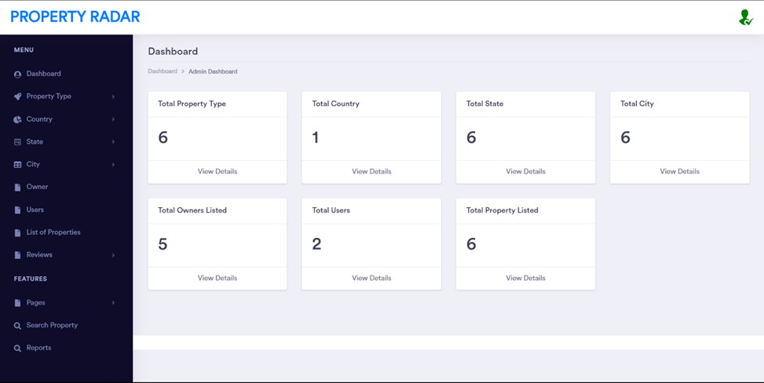

*Figure 14 Admin panel*

**Database**: Figure 15 Below represents the database structure. This is where all the data is stored. On this page, you have access to the tbladmin which stores the admin information, tblcity which stores city data, tblcountry which stores the country data, tblenquiry which stores all enquiry approve and nonapproved, tblfeedback which stores all the feedback given on the property, tblpage which stores the about and contact us pages data, tblproperty which stores all the uploaded property data for example address, price, status and so on, tblpropertytype which stores all the property type data, tblstate which stores the states data, and tbluser which stores all the user data such as name, address, phone number, email address and so on.

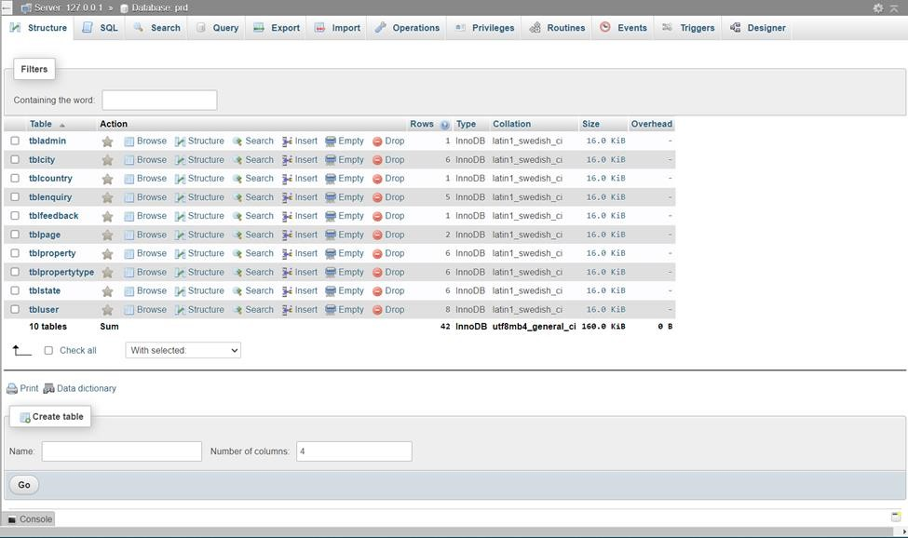  *Figure 15 Database panel*

5.2 HOW TO RUN THE WEB APPLICATION.

## 5.3

In order to test and run the proposed real estate management web application, it is required to follow the below hardware and software requirements.

1. **Hardware Requirement:** 
   * Any processor, preferable from Celeron above
   * Any window version, preferable from windows 8 above
   * Processor speed 2.0 GHz
   * Read Access Memory (Ram): 2gb
   * Hard disk: 50 to 200gb should be enough.

1. **Software Requirement** 
   * IDE: Visual studio codes
   * JavaScript language for scripting the application
   * HTML for the Font-End
   * Apache for the application server
   * MySQL for the application Database
   * PHP for the application back-end

## 5.4 SYSTEM IMPLEMENTATION

This part of the report shows the features of the web application and the functionality together with the source code snippet.

### 5.4.1 LOGIN SCREEN

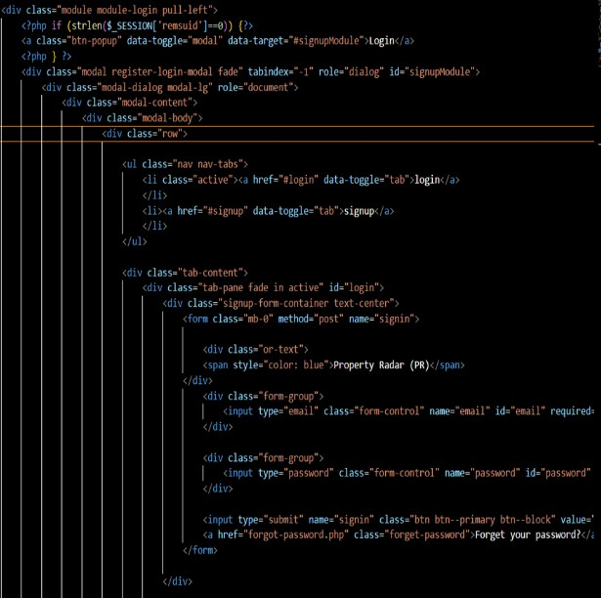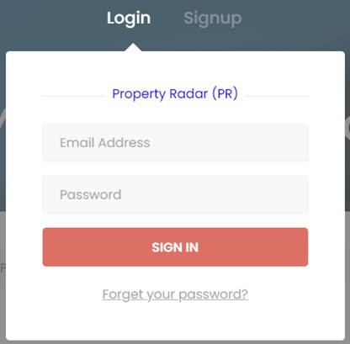

*Figure*

*16*

*Login*

*page*

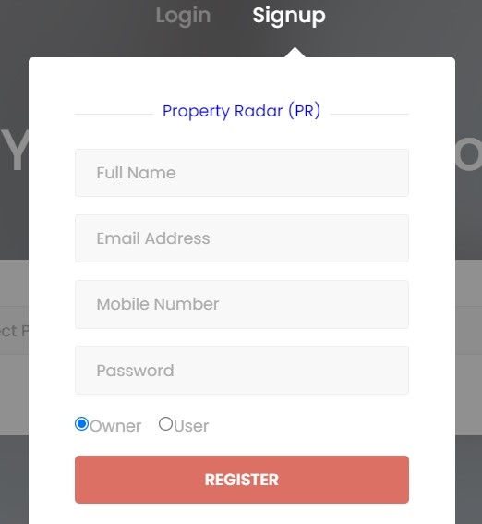

*Figure 17*

*Sign Up page*

*Figure 18 Code snippet*

**Figure 16** represents the login screen which enable new user to sign up for new account after opening the site and it allow an existing user login straight into their respective account because their login details has been saved on the database. You can request for change of password if you forget your password as well with the forget your password feature. **Figure 17** shows the signup page for a new user that does not have an account yet and an owner account can also set up an account from the signup page. While the **figure 18** is the code sample for the login feature which can also be seen on the web-app source code when needed.

### 5.4.2 GUEST USER

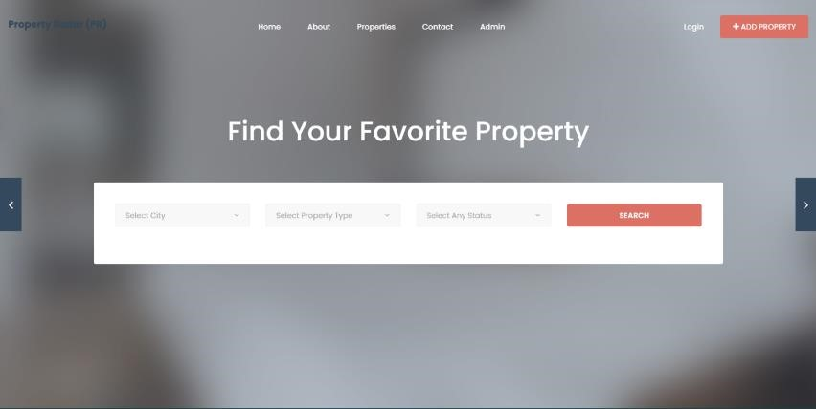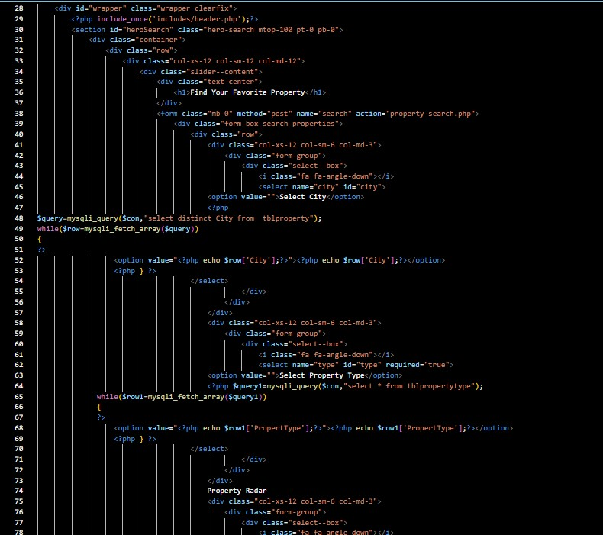

*Figure*

*19*

*The*

*guest user page*

*Figure*

*20*

*Code*

*sample*

**Figure 19** shows the Guest user screen where guests users can view and search for properties in respect to its city, property type and status. The guest users can also navigate to the about page, properties page, contact page and the Login. The guest user can’t add property until they login or sign up. **Figure 20** shows the code sample for the guest user page which can be seen on the web app source code when needed.

### 5.4.3 USER HOME SCREEN

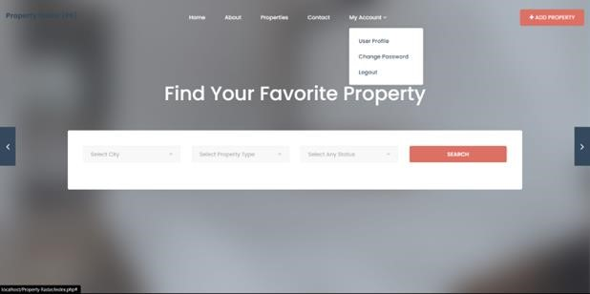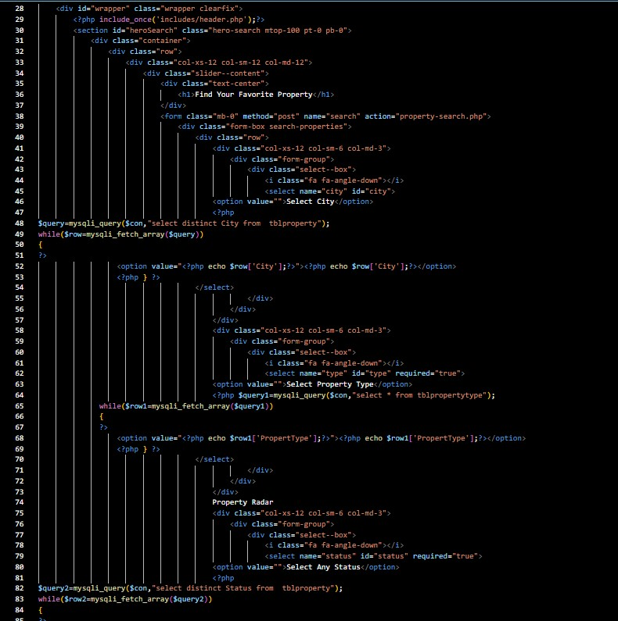

*Figure*

*21*

*User Home Screen*

*Figure 22 Code Sample*

**Figure 21** shows the user home screen where users can view and search for properties in respect to its city, property type and status. The user can also navigate to the about page, properties page, contact page, user profile, change password, log out and add property. The user can add properties and also leave reviews on properties. **Figure 22** shows the code sample for the guest user page which can be seen on the web app source code when needed.

### 5.4.4 ADMIN DASHBOARD

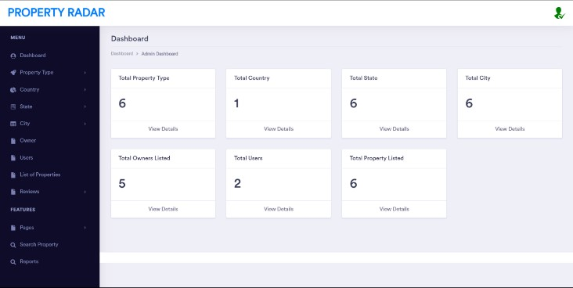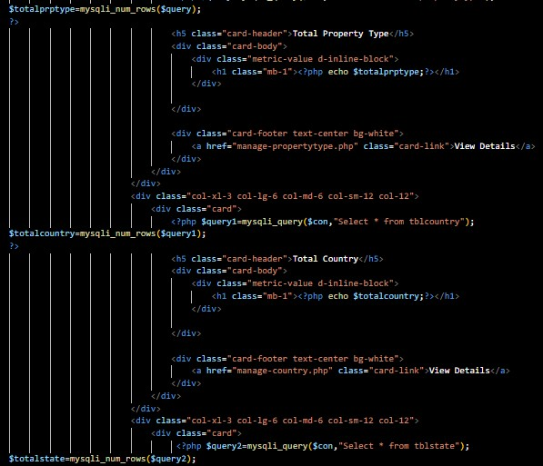

*Figure*

*23*

*Admin Dashboard*

*Figure*

*24*

*Code sample*

**Figure 23** shows the admin dashboard which is restricted to the administrator. In this page the administrator can manage and view the properties, users, owners, about page, contact page and reviews. The administrator can update the total property type, total country, total state, total city, total owners listed, total users and the total property listed. **Figure 24** shows the code sample for the guest user page which can be seen on the web app source code when needed.

### 5.4.5 USER PROFILE PAGE

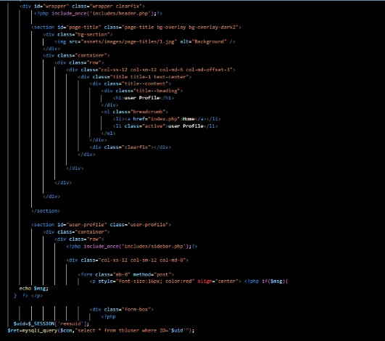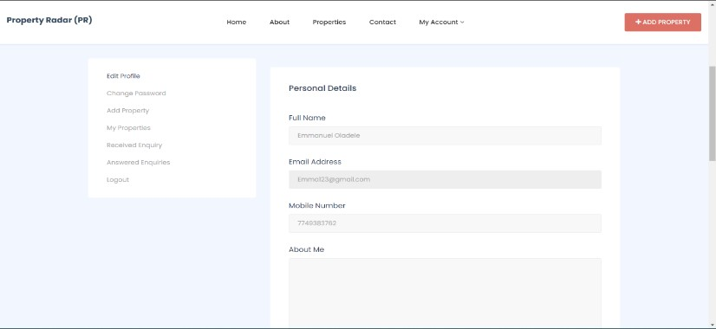 *Figure 25 User Profile page*

*Figure 26 Code Sample*

**Figure 25** shows the user profile page where users can edit the personal details, change password, add property, my properties, received enquiry, answered enquiries and logout. On this page users can change personal details like full name, email address, mobile number and about me (brief description of themselves). **Figure 26** shows the code sample for the guest user page which can be seen on the

web app source code when needed.

### 5.4.6 MORTGAGE CALCULATOR

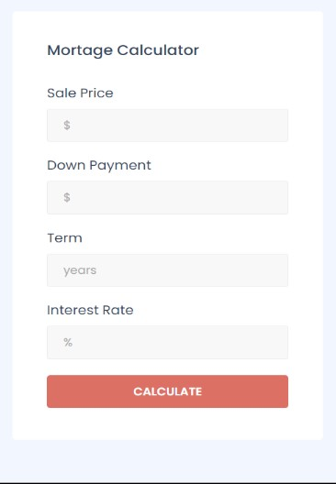

*Figure 27 mortgage calculator*

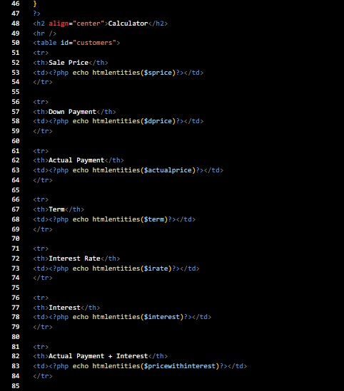

*Figure 28 code sample*

**Figure 27** shows the mortgage calculator which can be found at the property page. On this tab users can calculate the how much your yearly mortgage payment will be based on the sale price and the down payment. **Figure 28** shows the code sample for the guest user page which can be seen on the web app source code when needed it contains the formular used to develop the calculator.

### 5.4.7 ADMIN LOGIN PAGE

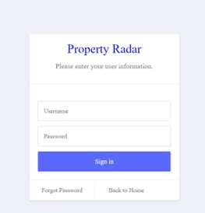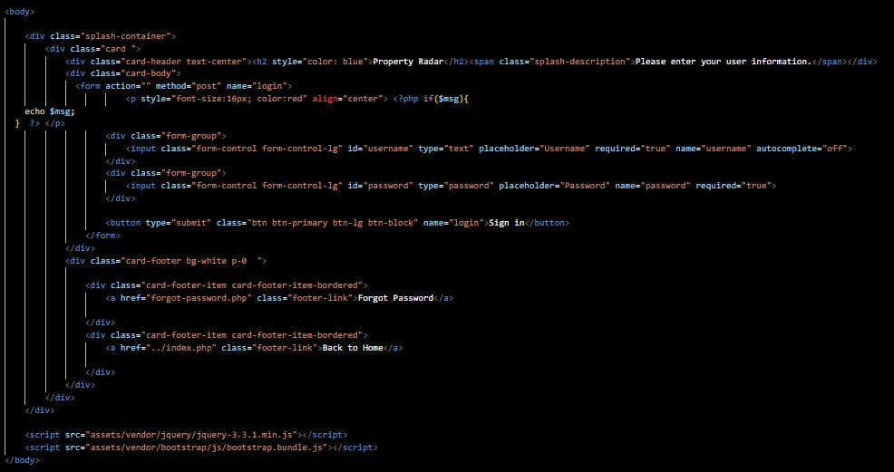

*Figure 29 Admin login page*  *Figure 30 code sample*

**Figure 29** shows the admin page which is restricted to the administrator alone. It allows the administrator log straight into the admin account because the admin login details has been saved on the database. You can request for change of password if you forget your password as well with the forget your password feature. **Figure 30** shows the code sample for the guest user page which can be seen on the web app source code when needed it contains the formular used to develop the calculator.

### 5.4.8 CHOICE OF PROGRAMMING LANGUAGE

The proposed real estate management system which is web application-based system. The proposed project was developed with HTML, CSS, and JAVASCRIPT programming language and SQL Server for storing the customers information and data.

### 5.4.9 HTML - (HYPER-TEXT MARKUP LANGUAGE)

This is a conventional markup machine language for Web pages, internet applications, and papers that are intended to be viewed in an internet browser. It not only instructs the web browser on how to display the content but also provides an explanation of the structure of the website itself. HTML, which stands for "Hyper Text Markup Language," is a standard machine language that is utilised in the development of the majority of functional websites as well as web applications. " Tim Berners-Lee and Robert Cailliau" initially developed HTML in 1980 as a project for "CERN (”Conseil Européen pour la Recherche Nucléaire”)", and it was later made available to the public in 1989 along with the help of other people. It is possible for innovations such as (CSS) and scripts such as JavaScript to be of assistance in this endeavor.

### 5.4.10 CSS - (CASCADING STYLE SHEETS)

This is a language for style sheets that is being used to structure the design of a website or web application. It is utilised in order to define the presentation of a piece of writing that was composed in a html code such as HTML. In addition to HTML and JavaScript, cascading style sheets (CSS) are an essential component of the Internet. Using CSS, you are able to control the color, font style, this same length of text, the padding among elements, how elements are located and set out, what images or backstory shades are to be used, as well as various showcases for various devices and display sizes. In addition, you can control the spacing between components using CSS. Hakon Wium hinge developed what is now known as CSS (Cascading Style Sheets) in 1994 while working at "CERN ("Conseil Européen pour la Recherche Nucléaire")". 1996 saw the debut of the very first version of the cascading style sheet. 1998 saw the release of CSS 2, as well as the beginning of development on CSS 3. CSS 3, in contrast to its predecessors, was not a single, all-encompassing set of requirements; rather, it was distributed as a collection of individual documents referred to as components. This marked a significant departure from previous versions of CSS.

### 5.4.11 JAVASCRIPT

Along with HTML and CSS, this programming language is considered to be one of the fundamental technologies that underpin the World Wide Web. Over 97 percent of websites incorporate third-party libraries and use JavaScript for client-side web page actions. This practice makes up the majority of JavaScript usage. Every major internet browser incorporates a JavaScript engine, which is responsible for implementing the commands on clients' devices. In 1995, Brendan Eich was the one who developed JavaScript. It was originally developed for Netscape 2, but by 1997 it had also become the requirement for ECMA-262. After JavaScript development had been handed over to ECMA by Netscape, the Mozilla structure continued to develop the language for use in the Firefox web browser.

### 5.4.12 SQL (STRUCTURED QUERY LANGUAGE)

This is a language that is specific to the domain that is used for querying, erasing, and updating the data sources that are being used. This is designed for handling data kept in a relational database administration system, as well as for stream handling in a relational information stream administration system, and it is also used in shows. In particular, it is useful for managing structured information, which can be defined as data that integrates relations between different entities and variables. In the 1970s, IBM's Donald Chamberlin and Raymond Boyce, along with the assistance of follow up (Structured English Question Language), were responsible for presenting SQL to the general public for the first time.

### 5.4.13 PHP (Hypertext Preprocessor)

This is a backend high - level programming language that is utilized quite frequently in the process of developing web apps or webpages. PHP is a powerful tool that can be used to create web pages that are both vibrant and interactive. Web applications, static websites, and dynamic websites can all be developed using this server-side scripting language, which is encoded with HTML. Rasmus Lerdorf is the one who developed PHP in the year 1994. It consisted of a fundamental collection of Common Gateway Interface (CGI) binaries that were written in the C programming language. Personal Web page was an earlier name for what is now known as PHP.

### 5.4.14 DEVELOPER'S ENVIRONMENT

The table below shows the languages and IDE used in the development of the system.

|  |  |
| --- | --- |
| Server-side programming language | PHP (Hypertext Preprocessor) |
| IDE | Visual Studio Code |
| Server | Apache (Xampp) |
| Operating system | Microsoft Windows |
| Style sheet | CSS |
| Scripting Language | JavaScript |

*Table 2 Dev Environment*

## 5.5 CHAPTER SUMMARY

In this section, the minimum specifications needed to develop and evaluate the implementation were specified. The requirements have been segmented into the specifications of software and hardware, which are the software development tools. The source code for the software's execution was recorded in this section so that any potential viewer could get a concept of where the program was being carried out.

# 6 CHAPTER 6

## 6.1 PROJECT EVALUATION/TESTING AND FUTURE WORKS 6.2 TESTING

Testing is a procedure that is carried out in order to evaluate a piece of software or the whole thing as a whole in order to determine whether or not the requirements outlined by the client have been satisfactorily met "(Carlos Coronel, 2016)". The evaluation was predicated on the aforementioned functional and non-functional standards, which can be found in this record and refer to Need Analysis. The purpose of Need Analysis is typically to identify discrepancies, gaps, or exclusions in user requirements " (Amaral, 2008)". The evaluation was carried out by means of a sequence of actions that could be carried out in another location. The participant was led through the application in order to determine whether or not the application satisfies the requirements. After being led through the application, the participant was questioned regarding a number of particular issues. The testing was carried out using a program that is accessible online and is called Zoom meeting. A table with questions, answers, and responses was used in order to record the results of the testing. This table was used for a variety of purposes (see table listed below).

|  |  |  |
| --- | --- | --- |
| Questions | Answers (Yes/No) | Feedbacks |
| Can you log in or signup? | YES | I was able to log in and sign up by navigating to the login page with the login button. I think people will love to view their passwords and also confirm the password. |
| Are you able to search for properties in your preferred city? | YES | I was able to search and even filter by the property type |
| Were you able to filter the property location to specific cities | YES | I was able to filter the search to specific cities, specific property types, and property status |
| Were you able to view the location’s map in the web app? | YES | I was able to view the location of the property map in the web app. |
| Were you able to upload properties and update them? | YES | I was able to upload my properties, but I can’t view them.  That’s because the admin hasn’t approved it |
| Were you able to calculate mortgage in the web app | YES | I was able to calculate the mortgage. |
| From the admin perspective does it allow you to approve inquiries from users and owners | YES | I was able to view approved and nonapproved inquiries and approve and disapprove |
| From the admin perspective does it allow you to manage properties | YES | I was able to view and manage properties |
| From the admin perspective does it allow you to manage users? | YES | I was able to view and manage all the users |
| From your perspective was the web app user friendly | YES | It was very easy to navigate, read and manage. |

## 6.3 FUTURE WORKS

After the developing and also screening of the application, a number of weaknesses were determined based on the previous work with the property monitoring system which has actually not been fixed, to improve the system that has been developed, the weak point that needed to be deal with are listed below.

* Individuals will not be able to save searches, inspect the most recent search, or add a structure to their Favorites list because this capability is not supported by the system.
* The system doesn’t have transaction functions where users can pay for properties
* The system doesn’t not verify Identity card like NIN, international passport, and bank verification number

Due to the limited amount of time and resources, the application that was suggested was unable to develop solutions for the flaws that were discussed earlier or incorporate any recommendations. However, once everything was said and done, the application was able to fulfil all of the requirements necessary to make people's lives easier.

## 6.4 CHAPTER SUMMARY

The developed application was examined, and the result of the evaluation was recorded in this section. In addition, this section laid out the system's numerous vulnerabilities by suggesting possible upgrade that need to be done to the existing system.

# 7 CHAPTER 7

## 7.1 CONCLUSION, SUMMARY AND RECOMMENDATIONS

In addition, the chapter outlined some recommendations and possible directions for future work, both of which have the potential to significantly advance the prototype system. The complete summary of this research task is highlighted below in the summary that has been listed. At the same time, significant insights will undoubtedly be extracted from all of the work that was done in the research.

## 7.2 BRIEF SUMMARY

The term "land and structures thereon" can refer to an immovable home like this one, houses or accommodation in broad, as well as the land itself and the resources on it like plants, minerals, or water. This type of home is an example of an immovable home. In developing nations such as Nigeria, the most important real estate agent procedures have traditionally been carried out by hand up until this point.

This project's objective is to develop a mobile real estate management system that is capable of automating building monitoring. This monitoring is intended to cover both document and information monitoring. In order to deploy the job strategy, we will make use of a two-tiered distributed design that includes a database for the storage of data as well as a client-side application. Moreover, we will disperse the design across multiple servers.

## 7.3 CONCLUSION

As a result of the preparation and also execution of this task, as well as the information and also understanding obtained from users or people looking for real estate, a decision has been reached to the effect that the layout has actually reduced the distance between the companies and also possible/current clients. This allows customers to bypass the lengthy hand-operated process of purchasing homes as well as residential or commercial property, and as a result, it eliminates three different types of costs, which are the price of having to search, the cost of handling, and the deal cost. However, the packing time was quite lengthy; additionally, the design enables prospective customers (customers) and interested individuals to get in touch with the company or the proprietor in charge of the inquiries and responses systems.

If the Mobile Real Estate System were successfully implemented, there would be no longer be a need for videotape backups because all of the information pertaining to tenants, including their contact information, lease agreements, residential property features, maintenance fees, and payment histories, would be digitally saved in an electronic database with back-up facilities. This would eliminate the need for videotape loss. Both the application authorization procedures and the program that will be used to ensure that only accepted customers can access the information contained in the data source need to be developed. In addition, substantial data sources will be managed in a manner that is much more effective, and the program will be able to carry out search queries in a quick and timely manner.

## 7.4 RECOMMENDATION

In light of the conclusion presented earlier, I believe that a variety of business organizations should make use of the framework even though not only will it bring in foot traffic and serve as an exit for the advancement of numerous properties to a larger audience. this means, but it will also make it possible for customers to view a variety of structures and select one that more closely meets their needs. In addition, it will minimize the inconvenience of having to travel from one office to another.

# 8 REFRENCES

1. Bergsman Steve. (1997). Virtual reality. Journal of Property Management(Vol. 62, no. 1), 26 -

29.

1. Boudreaux, Karol . (2022, March 31). *Private property*. Retrieved from Wikipedia:

https://en.wikipedia.org/wiki/Private_property#:~:text=Private%20property%20is%20a%20l egal,group%20of%20non%2Dgovernmental%20entities.

1. Deakin, M. (2019, May 31). *Local Authority Property Management*. Retrieved from Taylor and francis group: https://www.taylorfrancis.com/books/edit/10.4324/9780429432873/localauthority-property-management-mark-deakin?refId=14afe74e-e41d-4656-bf330fac9a098cff&context=ubx
2. DM ConsultingServices. (2005, August). *Real Estate Management System*. Retrieved from DM Consulting Services: DM Consulting Services
3. Dragomir Simovic. (2022, March 11). *30+ Essential Real Estate Statistics*. Retrieved from Smallbizgenius: https://www.smallbizgenius.net/by-the-numbers/real-estatestatistics/#:~:text=52%25%20of%20home%20buyers%20say%20the%20main%20purpose,ter ms%20of%20sale%20or%20get%20a%20better%20price.
4. Georgiou, M. (2021, December 15). *13 Must-Have Features that Make a Winning Real Estate App in 2022*. Retrieved from Imaginovation Insider: https://imaginovation.net/blog/musthave-real-estate-app-features/
5. Gross,M. & Lin,C. (2020). COMPARISON OF REAL ESTATE MANAGEMENT. *Real Estate Management and Valuation*, 13-27.
6. James Chen. (2021, June 14). *REAL ESTATE INVESTING*. Retrieved from INVESTOPEDIA: https://www.investopedia.com/terms/r/realestate.asp
7. MIXTA AFRICA. (2022). *C of O – Meaning And Importance*. Retrieved from MIXTA AFRICA: https://mixtafrica.com/certificate-of-occupancy/
8. Nigeria Property Centre. (2022). *About Nigeria Property Centre*. Retrieved from Nigeria Property Centre: https://nigeriapropertycentre.com/
9. Oyedele, O. A. (2013, November). *Assessment of Property Management Practices in Nigeria.* Retrieved from Research Gate:

https://www.researchgate.net/publication/258439505_Assessment_of_Property_Managem ent_Practices_in_Nigeria#:~:text=Property%20management%20is%20still%20undefined%20 especially%20in%20Nigeria,in%20Lease%20Agreements%20between%20the%20landlords%2 0and%20tenant

1. Palm, P. (2015, September 29). *Challenges of Commercial Real Estate Management: An analysis of the Swedish commercial real estate industry*. Retrieved from Diva Portal:

http://www.divaportal.org/smash/record.jsf?dswid=4661&pid=diva2%3A857592&c=26&searchType=SIMPLE &language=en&query=palm&af=%5B%22personName%3A%5C%22Palm%2C+Peter%5C%22

%22%5D&aq=%5B%5B%5D%5D&aq2=%5B%5B%5D%5D&aqe=%5B%5D&noOfRows=50&sort

Order=author_sort_asc

1. PropertyPro.ng. (2020). *About PropertyPro.ng*. Retrieved from PropertyPro.ng:

https://www.propertypro.ng/about

1. Resolution Law Firm. (2021). *BUYING LAND IN NIGERIA – THE LEGAL REQUIREMENTS*. Retrieved from Resolution Law Firm: https://www.resolutionlawng.com/buying-land-innigeria/
2. Rightmove. (2021). *How we make the market more efficient for consumers*. Retrieved from Right Move: https://plc.rightmove.co.uk/about-us/what-we-do
3. Samson Itoje. (2022). *Lagos Nigeria Real Estate Fraud – Fraudsters and The Omoniles*. Retrieved from Lagos nigeria real estate advisors: http://www.lagos-nigeria-real-estateadvisor.com/nigeria-real-estate-fraud.html
4. Savills. (2021). *Why Savills*. Retrieved from Savills: https://www.savills.co.uk/why-savills/ 18. The Stay Club. (2021). *The Stay Club Camden*. Retrieved from The Stay Club: https://www.thestayclub.com/student-accommodation/camden/
5. Watson, J. A. (1977, April 6). *Savills*. Retrieved from Wikipedia:

https://en.wikipedia.org/wiki/Savills

1. Wikipedia. (2022, 4 17). *Property management system*. Retrieved from Wikipedia The free encyclopedia:

https://en.wikipedia.org/wiki/Property_management_system#:~:text=Property%20Manage ment%20systems%20allow%20local,%2C%20communication%2C%20and%20tenant%20satis faction.

1. Bergsman Steve. (1997). Virtual reality. Journal of Property Management(Vol. 62, no. 1), 26 -

29.

1. Boudreaux, Karol . (2022, March 31). Private property. Retrieved from Wikipedia:

https://en.wikipedia.org/wiki/Private_property#:~:text=Private%20property%20is%20a%20l egal,group%20of%20non%2Dgovernmental%20entities.

1. Deakin, M. (2019, May 31). Local Authority Property Management. Retrieved from Taylor and francis group: https://www.taylorfrancis.com/books/edit/10.4324/9780429432873/localauthority-property-management-mark-deakin?refId=14afe74e-e41d-4656-bf330fac9a098cff&context=ubx
2. Dragomir Simovic. (2022, March 11). 30+ Essential Real Estate Statistics. Retrieved from Smallbizgenius: https://www.smallbizgenius.net/by-the-numbers/real-estatestatistics/#:~:text=52%25%20of%20home%20buyers%20say%20the%20main%20purpose,terms%20of%20sale%20or%20get%20a%20better%20price.
3. Gross,M. & Lin,C. (2020). COMPARISON OF REAL ESTATE MANAGEMENT. Real Estate Management and Valuation, 13-27.
4. James Chen. (2021, June 14). REAL ESTATE INVESTING. Retrieved from INVESTOPEDIA: https://www.investopedia.com/terms/r/realestate.asp
5. MIXTA AFRICA. (2022). C of O – Meaning And Importance. Retrieved from MIXTA AFRICA: https://mixtafrica.com/certificate-of-occupancy/
6. Nigeria Property Centre. (2022). About Nigeria Property Centre. Retrieved from Nigeria Property Centre: https://nigeriapropertycentre.com/
7. Palm, P. (2015, September 29). Challenges of Commercial Real Estate Management: An analysis of the Swedish commercial real estate industry. Retrieved from Diva Portal:

http://www.divaportal.org/smash/record.jsf?dswid=4661&pid=diva2%3A857592&c=26&searchType=SIMPLE &language=en&query=palm&af=%5B%22personName%3A%5C%22Palm%2C+Peter%5C%22

%22%5D&aq=%5B%5B%5D%5D&aq2=%5B%5B%5D%5D&aqe=%5B%5D&noOfRows=50&sort

Order=author_sort_asc

1. PropertyPro.ng. (2020). About PropertyPro.ng. Retrieved from PropertyPro.ng:

https://www.propertypro.ng/about

1. Resolution Law Firm. (2021). BUYING LAND IN NIGERIA – THE LEGAL REQUIREMENTS. Retrieved from Resolution Law Firm: https://www.resolutionlawng.com/buying-land-innigeria/
2. Rightmove. (2021). How we make the market more efficient for consumers. Retrieved from Right Move: https://plc.rightmove.co.uk/about-us/what-we-do
3. Savills. (2021). Why Savills. Retrieved from Savills: https://www.savills.co.uk/why-savills/ 34. The Stay Club. (2021). The Stay Club Camden. Retrieved from The Stay Club: https://www.thestayclub.com/student-accommodation/camden/
   1. Watson, J. A. (1977, April 6). Savills. Retrieved from Wikipedia:

https://en.wikipedia.org/wiki/Savills

* 1. Wikipedia. (2022, 4 17). Property management system. Retrieved from Wikipedia The free encyclopedia:

https://en.wikipedia.org/wiki/Property_management_system#:~:text=Property%20Manage ment%20systems%20allow%20local,%2C%20communication%2C%20and%20tenant%20satis faction.

# 9 APPENDIX

## 9.1 APPENDIX “A” MEETING LOG WITH SUPERVISOR

NAME: **Oladele Emmanuel Ayobola**

STUDENT NUMBER: **M00859474**

|  |  |  |
| --- | --- | --- |
| **Date** | **Comments** | **Supervisor's signature** |
| 3/7/2022 | Proposal Feedback |  |
| 3/22/2022 | Literature review feedback |  |
| 3/25/2022 | Literature review draft feedback |  |
| 3/30/2022 | Second Literature review draft feedback |  |
| 5/11/2022 | Final Report feedback |  |

9.2 APPENDIX “B” ETHICS FORM

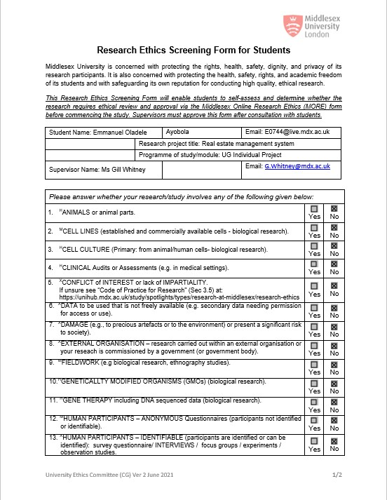



9.3 CONSENT FORM

## 9.4 OTHER

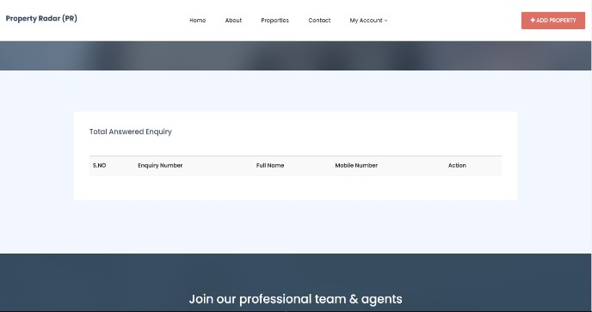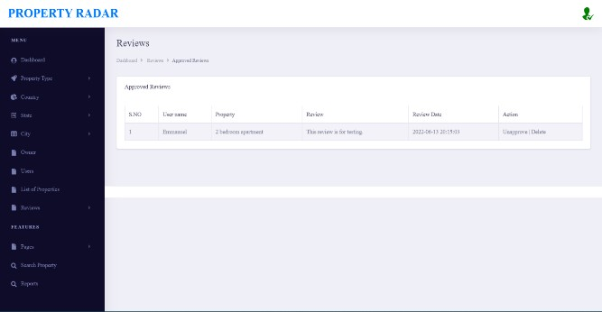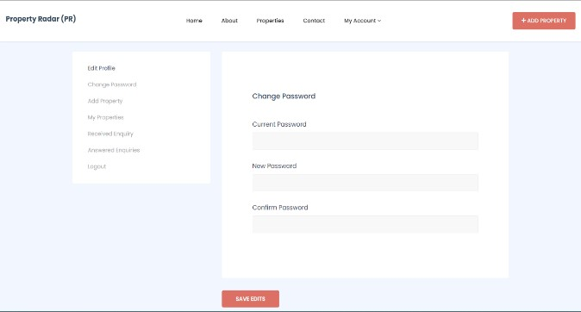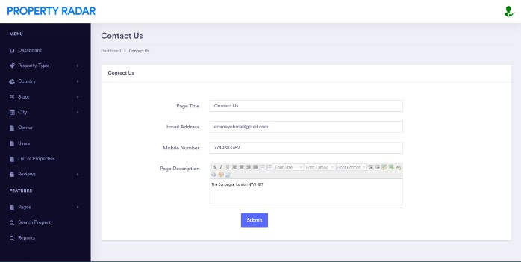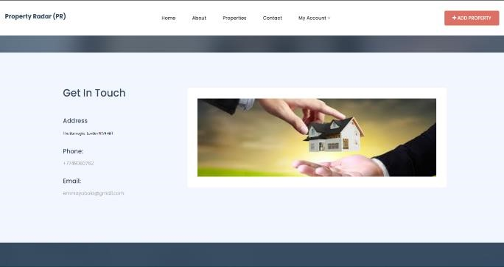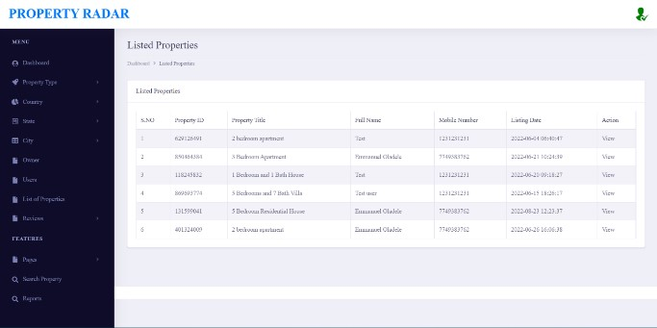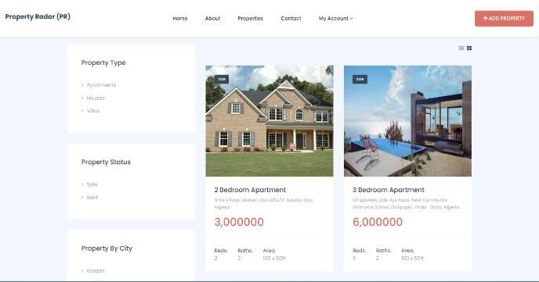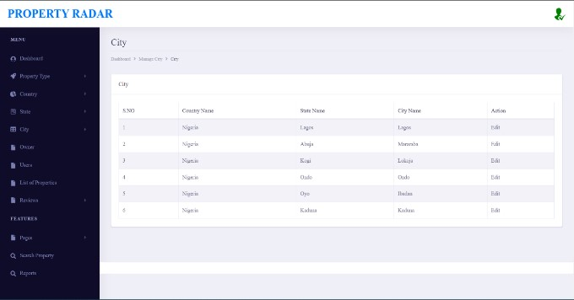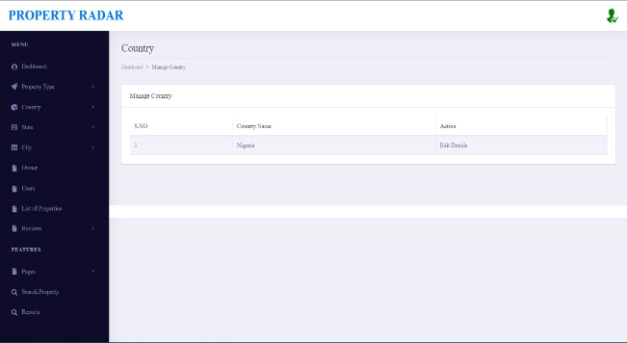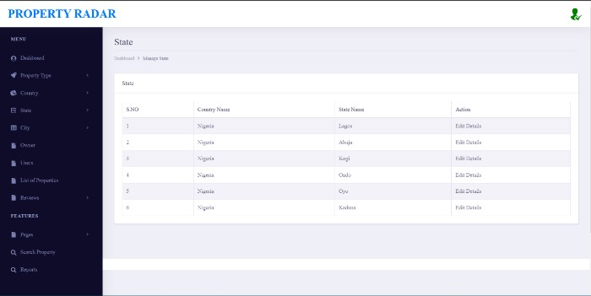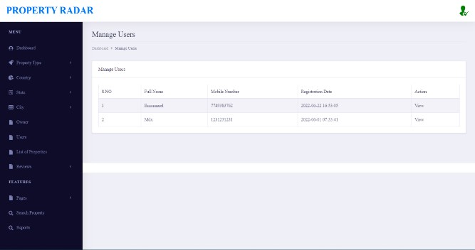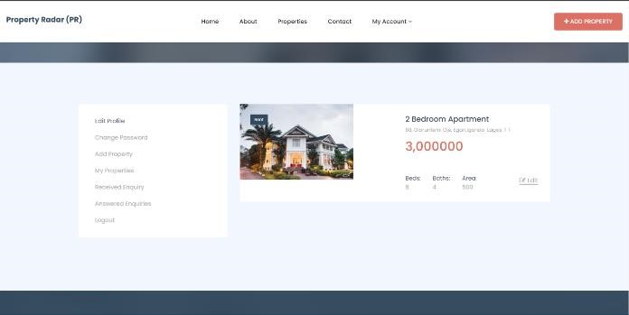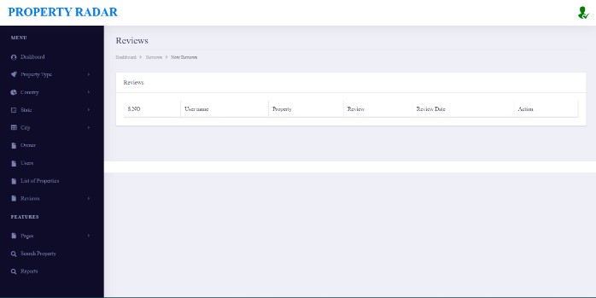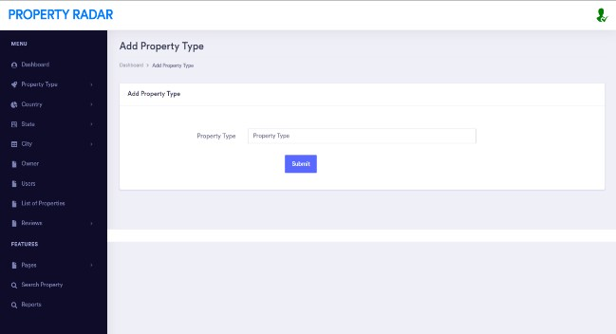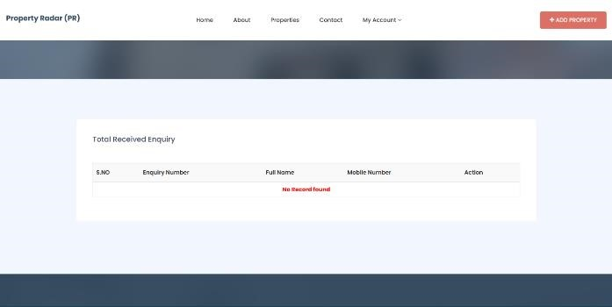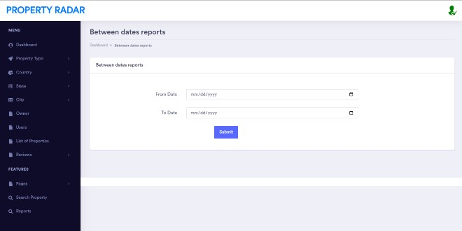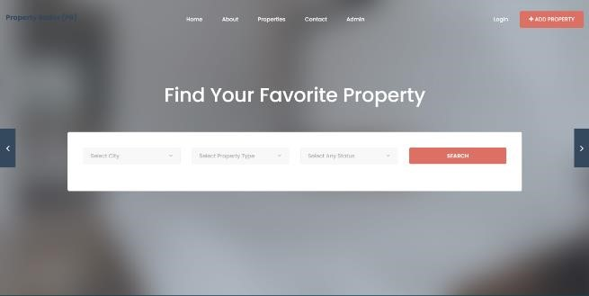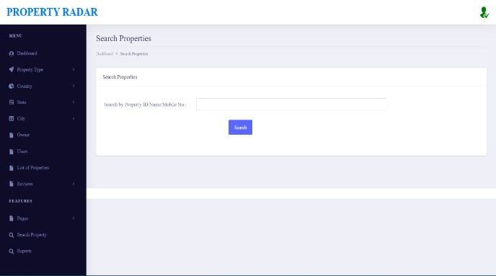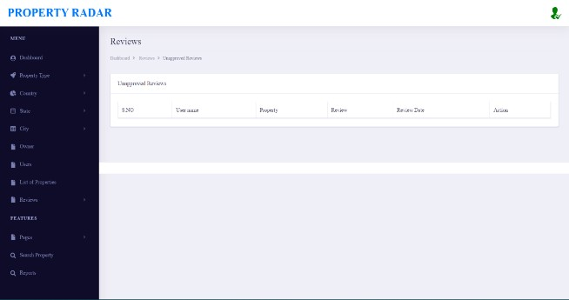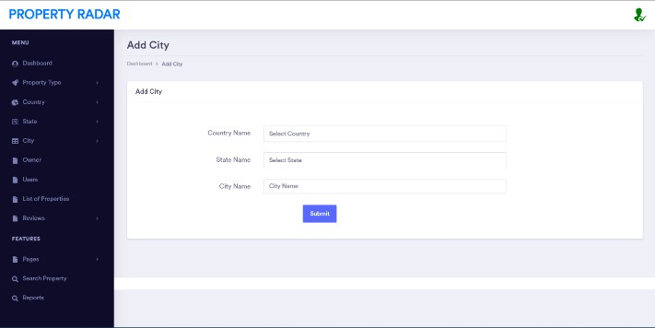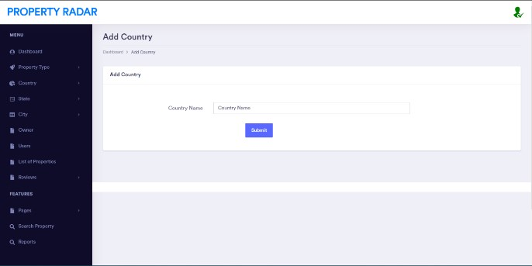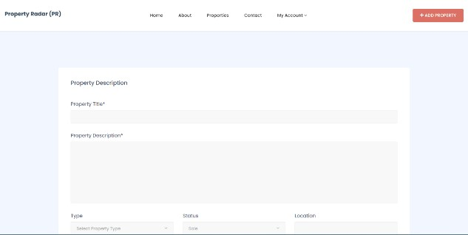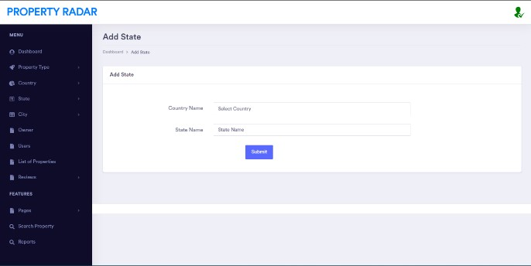

### 9.4.1.1